Blockchain Assignment 11
- Write, compile, and show the deployment output of a smart contract with the following functions

- A function to perform pre increment operation on an uint256 variable.

Below variable holds output of pre increment:
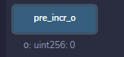
After execution of pre increment function:
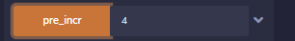
Value changed to 5:
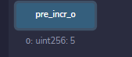

- A function to perform post increment operation on an int256 variable.

Below variable holds output of post increment:
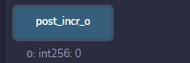
After execution of post increment function:
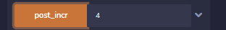
Value not changed:
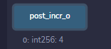

- A function to perform pre decrement operation on an int256 variable.
Below variable holds output of pre decrement:
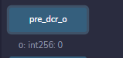
After execution:
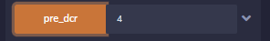
Value updated as:
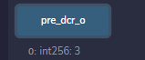

- A function to perform post decrement operation on an uint256 variable.
Below variable holds output of post decrement:
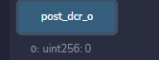
After execution:

Value changed to:
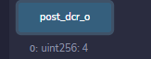

Code below:
//SPDX-License-Identifier:MIT

pragma solidity ^0.8.0;

contract incr_decr_operations{
uint256 public pre_incr_o; // pre incremet output variable
int256 public post_incr_o; // post increment output variable
int256 public pre_dcr_o; // pre decrement variable
uint256 public post_dcr_o; // post decremet variable

// pre inrement operation
function pre_incr(uint256 _a) public returns (uint256)
{
pre_incr_o = ++ _a;
return pre_incr_o;
}

function post_incr(int256 _b) public returns (int256)
{
post_incr_o = _b++;
return post_incr_o;
}

function pre_dcr(int256 _c) public returns (int256)
{
pre_dcr_o = --_c;
return pre_dcr_o;
}

function post_dcr(uint256 _d) public returns (uint256)
{
post_dcr_o = _d--;
return post_dcr_o;
}
}

